Hello World RESTful Web Service
SCREENSHOT
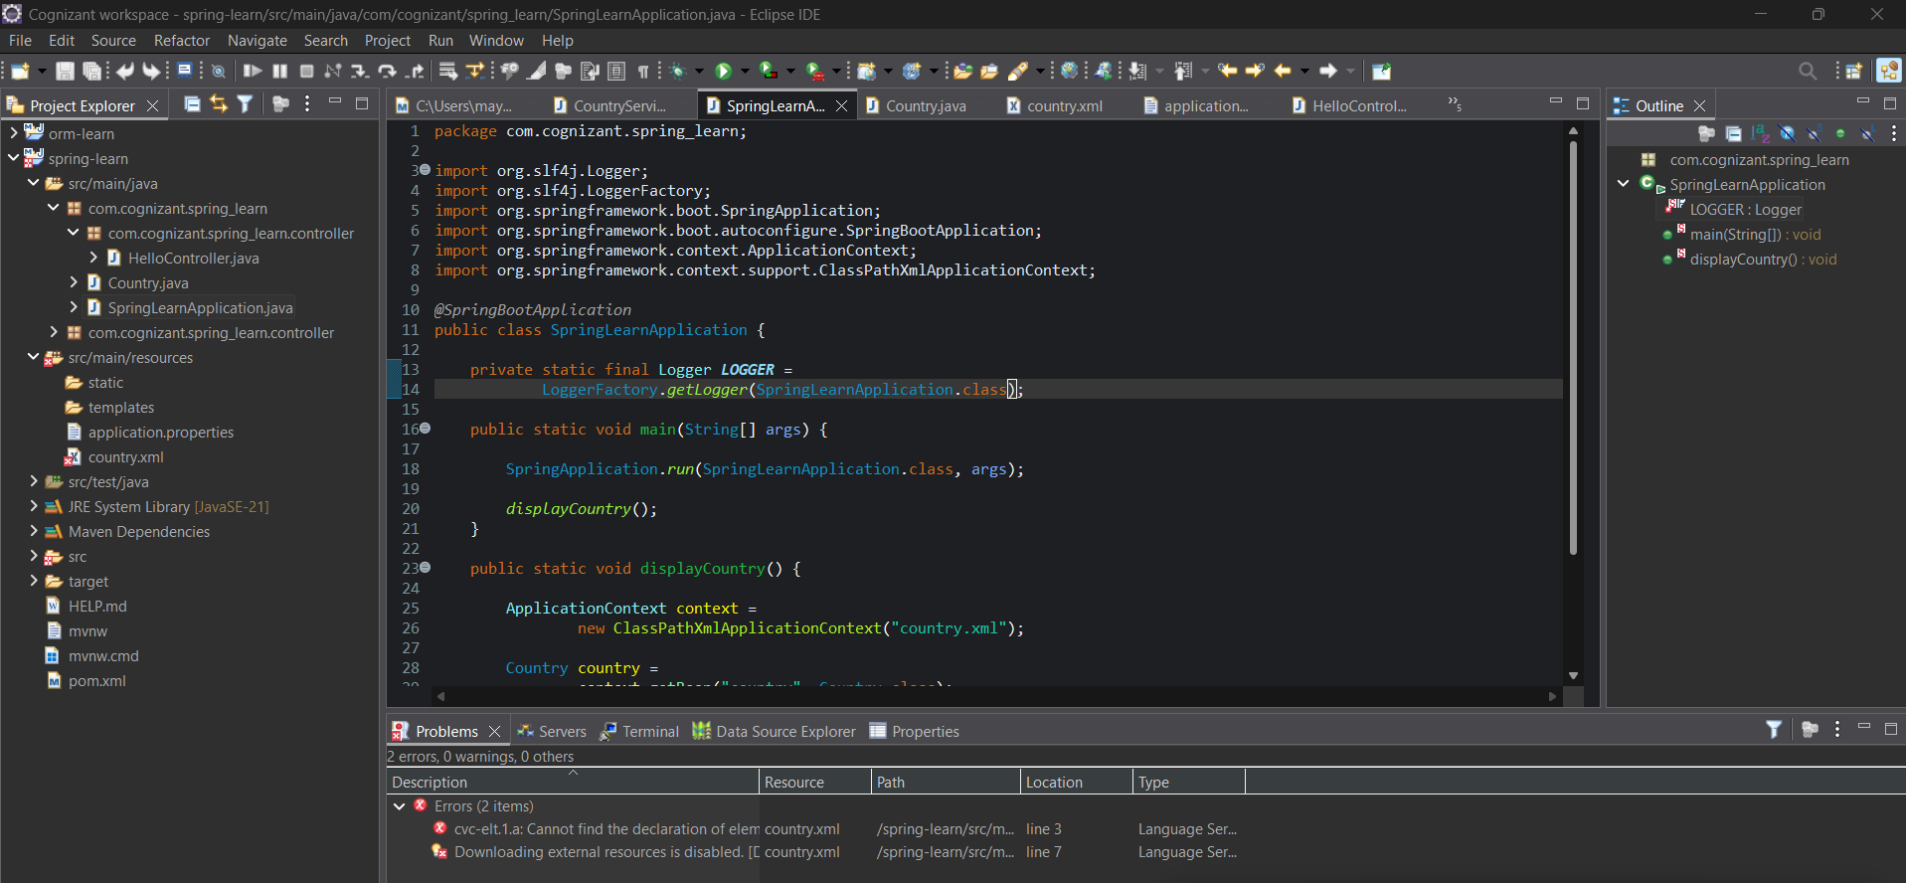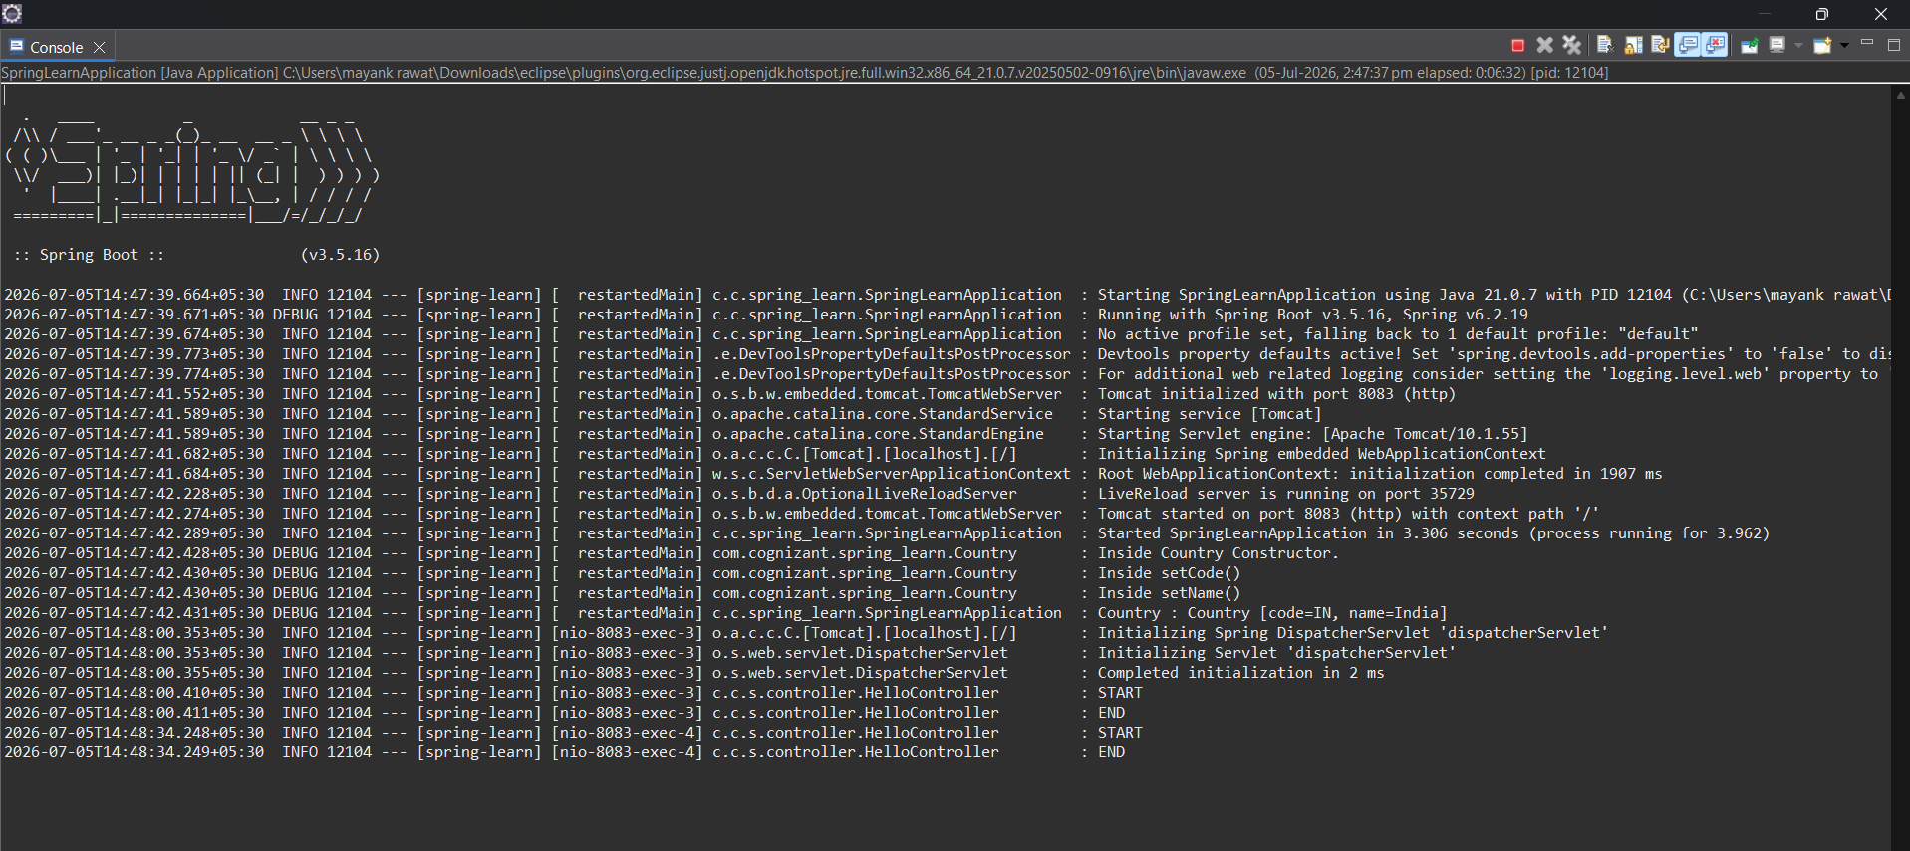

SpringLearnApplication.java
package com.cognizant.spring_learn;
import org.slf4j.Logger;
import org.slf4j.LoggerFactory;
import org.springframework.boot.SpringApplication;
import org.springframework.boot.autoconfigure.SpringBootApplication;
import org.springframework.context.ApplicationContext;
import org.springframework.context.support.ClassPathXmlApplicationContext;
@SpringBootApplication
public class SpringLearnApplication {
private static final Logger LOGGER =
LoggerFactory.getLogger(SpringLearnApplication.class);
public static void main(String[] args) {
SpringApplication.run(SpringLearnApplication.class, args);
displayCountry();
}
public static void displayCountry() {
ApplicationContext context =
new ClassPathXmlApplicationContext("country.xml");
Country country =
context.getBean("country", Country.class);
LOGGER.debug("Country : {}", country.toString());
((ClassPathXmlApplicationContext) context).close();
}
}

Application.properties
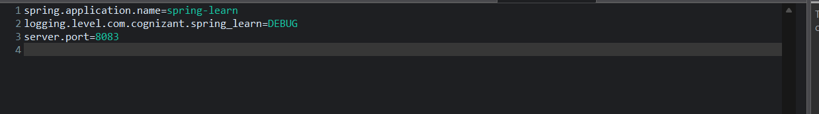

HelloController.java
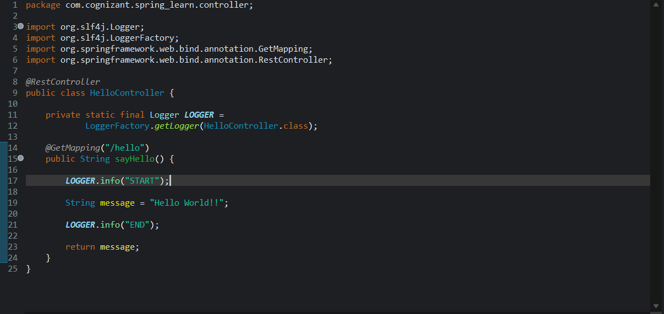

SME Questions

1. What is @RestController?
Marks the class as a REST Controller.
It combines:
- @Controller
- @ResponseBody
It tells Spring to return the method's return value directly in the HTTP response body.

2. What is @GetMapping?
Maps an HTTP GET request to a Java method.
@GetMapping("/hello")
means:
GET /hello
calls
sayHello()

